01.02.2022
L.O I can count forwards and backwards within 50.

- Complete the number tracks.
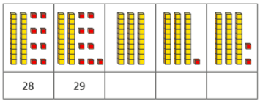

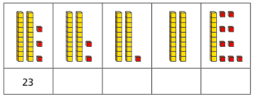

- Complete the number tracks.
