Week beginning Monday 1st March 2021
Monday | Fitness Frenzy from GSSP | Maths  Algebra- Solve one-step equations  Lesson Video | English Writing Workshop with author: Simon James Green |  | 11am Join hilarious writer Simon James Green for a lesson in writing all things funny  Use this link to join | Reading Plus | TTRS | Geography  Lesson video  Google Earth Savanna  Google Earth Temperate Deciduous Forest  Video 1  Video 2
Tuesday | Fitness Frenzy from GSSP | Maths  Algebra – Solve two-step equations  Lesson Video | English  Wolf on Trial  Big Foot Theatre Production  Video Lesson  Wolf on Trial Verdicts:  Guilty Video Link  Not Guilty Video Link  Resources are underneath timetable |  |  | Reading Plus | TTRS | Roald Dahl Story Detectives  Big Foot Theatre Production  Video Lesson | 2:30pm - Virtual Get together  Please sign in to your Microsoft account to join our Teams ‘Class Catch Up’
Wednesday | Fitness Frenzy from GSSP | Maths  Algebra - Find pairs of values (1)  Lesson Video | English  World Book Day Task – Follow up from Live Lesson  Creating a Maths Story  Video Lesson  Mouse Shapes Video Link  One is a snail Ten is a Crab Video Link |  |  | Reading Plus | TTRS | Art  See the poster below the timetable
Thursday | Fitness Frenzy from GSSP | Maths  Algebra - Find pairs of values (2)  Lesson Video | Join Thiago de Maraes live. Get ready to go back in time with Thiago and draw some great characters from history.  Use this link | 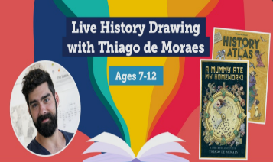  World Book Day Event live workshop |  | Reading Plus | TTRS | Art  Origami project with artist, Simon Turner.  See tutorial  Video Link |  | 2:30 pm Virtual Get Together  Please sign in to your Microsoft account to join our Teams ‘Class Catch Up’
Friday | Fitness Frenzy from GSSP | Maths  Algebra – End of unit assessment  Lesson Video | English  Comic poetry Competition  See the poster underneath the timetable |  |  | Reading Plus | TTRS | No screen afternoon  Relax and try to have some screen-free time

