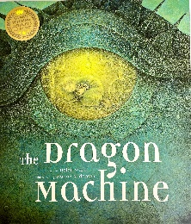
The Dragon Machine

would | helpful | train
could | behave | dragon
should | unnoticed | George
advice | believe | listen

