Voice One (Mother) | Voice Two (Dad)
 | 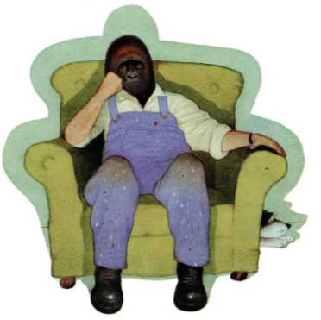
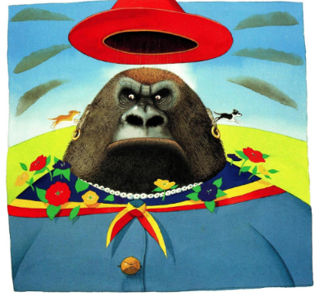
Live in a nice house
Upright – straight posture – boy is hidden
Expensive clothes and jewellery
Scruffy mongrel – bothering her – shood of – horrible thing
Back to each other – stern face
Voice Three (Charlie) | Voice Four (Smudge)
 | 