10.3.21
LO: To make numbers in different ways
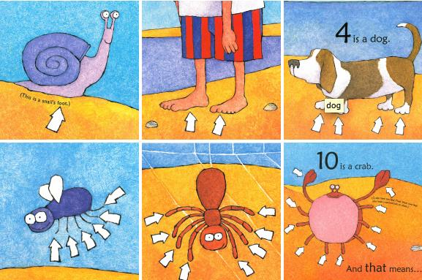
On World Book Day, we read a brilliant story all about feet! This helped us to explore how different numbers can be made.
1 is a snail.
2 is a person.
4 is a dog.
6 is an insect.
8 is a spider.
10 is a crab.

Number | a) | b)

