Tuesday 17th November
LO: To be able to correctly identify a variety of transparent, translucent and opaque objects
 | Me | Teacher
I predict cause & effect (causal prediction) using my knowledge of light energy. *
I predict a trend (relationship prediction). **
I use K&U to explain my prediction (relationship). ***
Write down your own definitions for:
Transparent: ................................................................................................
Translucent: .................................................................................................
Opaque: .........................................................................................
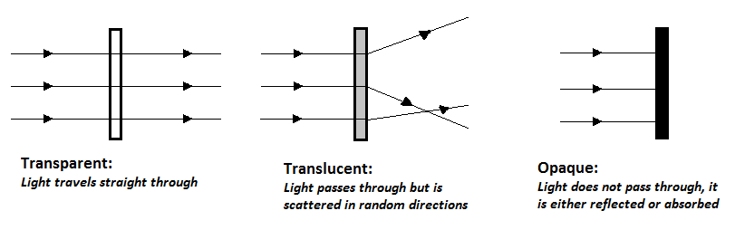
- Look around the room and classify as many objects as you can find, is the object transparent, translucent or opaque?
Material | Prediction | Result

