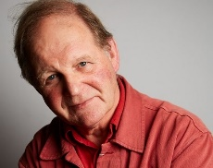
Question Generator: Questions for Michal Morpurgo
 | is/was | did/do | would/could
What?
Where?
When?
Who?
How?
Why?
If?

