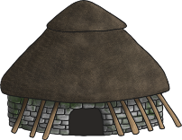
Friday 9th October
LO: To design and construct a Stone-Age dwelling using clay, sticks and hay.
What will I need: | Photo of finished design:
Design plan:

Evaluation: What do you like about your design? What would you improve?

______________________________________________________

______________________________________________________

______________________________________________________

______________________________________________________
