Monday 19th October
LO: I can use an atlas to name and locate the main rivers and seas of the UK.

Complete the labels to show each of the seas around the UK.
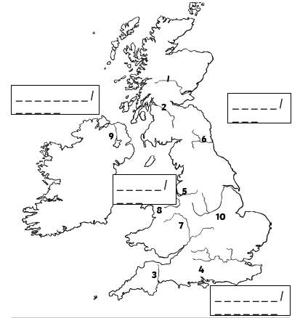

Fill in the table to show where each of these rivers are in the UK, and the sea that each one flows into.
