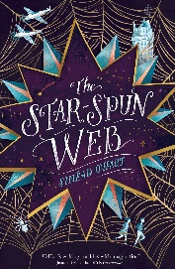
WC 29/11/21

- What season was it?
- What was the man carrying when he was running?
- Who has he lost recently?
- What did the men do to him after they circled him?
- What happened to the baby?

WC 29/11/21

- What season was it?
- What was the man carrying when he was running?
- Who has he lost recently?
- What did the men do to him after they circled him?
- What happened to the baby?

WC 29/11/21

- What season was it?
- What was the man carrying when he was running?
- Who has he lost recently?
- What did the men do to him after they circled him?
- What happened to the baby?

