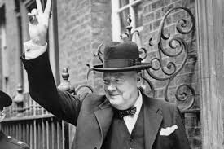
Wb 29.11.21 L.O: To understand why Winston Churchill was such a significant prime minister.
Where did Churchill go to school?
In what year was
Winston Churchill born?
Keywords: Winston Churchill Prime minister Britain World War 2 significant famous speeches Why Where What

