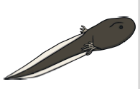 | 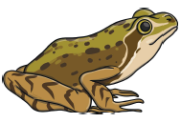 |  | 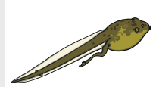
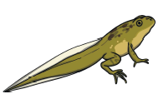 |  |  | 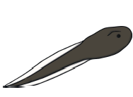
Once the tail has shrunk to just a stub and the lungs have replaced the gills, the froglet leaves the water and can live on land. It continues to grow in size until it becomes and adult frog. |  | Eggs are laid in clumps (spawn) in water, often in shallow areas. Spawn appears in spring, usually in Ferbruary or March
Over the next 14 weeks, the tadpole eats plants and develops, growing two hind legs |  | Over 7 to 9 days, embryoys develop inside the eggs. These develp and hatch into tadpoles.
The tadpoles develop gills – feathery organs that absorb dissolved oxygen in the water. Carbon dioxide passes out of the tadpole’s bloodstream through the gills. |  | The tadpole grows two front legs. The tail becomes shorter, as it is absorbed into its body. It stops eating vegetation, using only the nutrients stored in its tail. It also develops lungs.

Once the tail has shrunk to just a stub and the lungs have replaced the gills, the froglet leaves the water and can live on land. It continues to grow in size until it becomes and adult frog. |  | Eggs are laid in clumps (spawn) in water, often in shallow areas. Spawn appears in spring, usually in Ferbruary or March
Over the next 14 weeks, the tadpole eats plants and develops, growing two hind legs |  | Over 7 to 9 days, embryoys develop inside the eggs. These develp and hatch into tadpoles.
The tadpoles develop gills – feathery organs that absorb dissolved oxygen in the water. Carbon dioxide passes out of the tadpole’s bloodstream through the gills. |  | The tadpole grows two front legs. The tail becomes shorter, as it is absorbed into its body. It stops eating vegetation, using only the nutrients stored in its tail. It also develops lungs.

