Wednesday 30th September
Content objective:
To investigate whether we can change the shape of materials
Me
Teacher
Skill objective:
To group by difference, similarity or change
Me
Teacher

 | Squash? | Bend? | Twist? | Stretch?
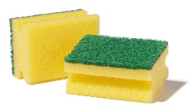

Sponge
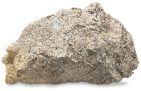

Stone
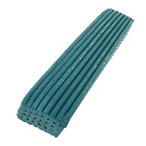

Plasticine
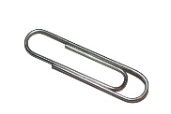

Metal
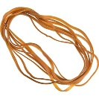

Rubber
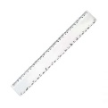

Plastic

