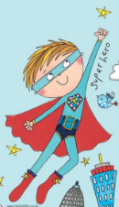
Nursery Home Learning ideas
Week Beginning Monday 25th January
Superhero Week/ Children’s Mental Health Week

Please also keep an eye on Tapestry for the links to the circle time, activity
and story sessions that we have record for the children each day.

There is also a mindfulness grid of pick and mix activities attached that children throughout school will be using.

Literacy
Start the week with a Superhero themed story
We will be posting a daily story time on Tapestry. Please watch that or read some books from your own collection. If you haven’t got any superhero books in your collection at home there are lots online that you can watch. Here are some of our suggestions:
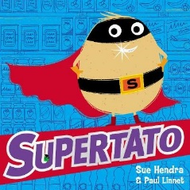
- Supertato:
https://www.youtube.com/watch?v=QlaMeNmTG6c
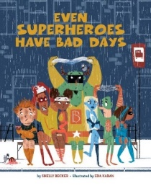
- Even Superheroes have bad days:
https://vimeo.com/216918288

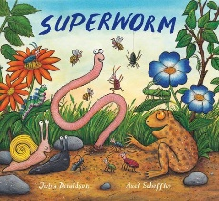
- Superworm:
https://www.youtube.com/watch?v=LRdbB_tRPsg

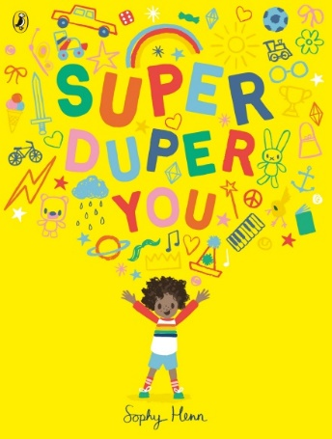
Super Duper You
https://www.youtube.com/watch?v=bFK_PLg0FYk
- Listen to the author Sophy Henn read the story then talk about what makes you ‘super duper’.
- Children could draw a picture to show themselves doing their super skill such as, bike riding, painting, singing etc.

Teddy Bear Meditation
During this pandemic, children may be feeling a range of uncomfortable emotions, including anxiety, worry or anger. It is important children know that it is OK to feel these emotions and that adults are also feeling them. However, children need strategies to help them deal with these uncomfortable emotions. One strategy to help children feel calmer is using meditation.
So, grab a teddy and use the attached meditation guide.

Cut and Stick Projects
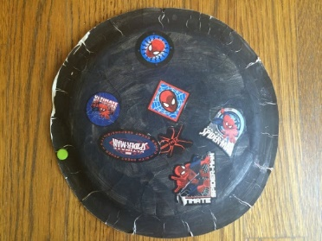
- Toilet roll superhero cuff
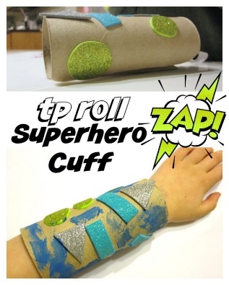

- Paper plate / cereal box shield?
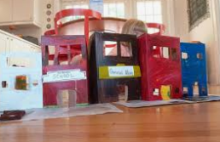
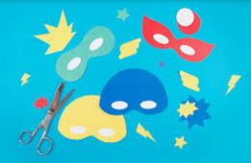
- Super hero mask

- Cereal box/ shoe box city

Superhero Exercise
- Football coaching session with Andrew Cartwright. https://youtu.be/nBltsG6YbFA
- Relax kids session- link to follow on Tapestry.
- Try the Joe Wicks workout live on YouTube at 9am Monday, Wednesday and Friday. Remember that Friday is fancy dress day with Joe!
- Try to learn one of the Superhero dances:
https://www.youtube.com/watch?v=3xf6hfq4pxk
https://www.youtube.com/watch?v=Dx59hSyY2ds
https://www.youtube.com/watch?v=ok7V1pWtRzs
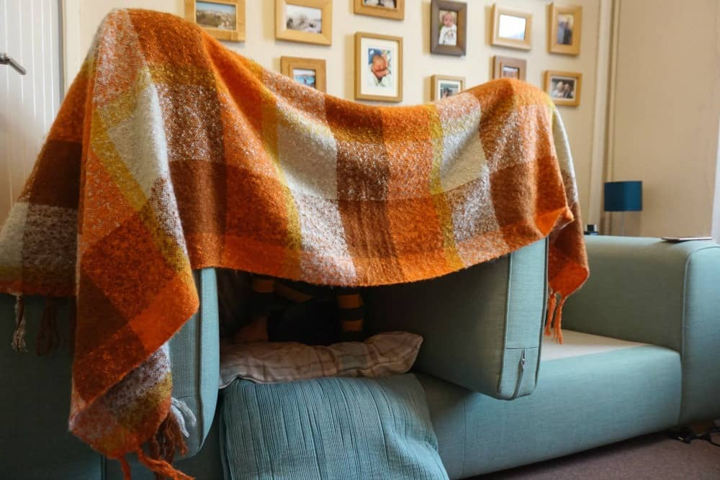
- Use your super strength to build a superhero hideout den from cushions and blankets

Maths
Use the link below:
https://whiterosemaths.com/homelearning/early-years/its-me-1-2-3-week-1/
Watch one video each day – from week 1 – sessions 1 to 5
Then have a go at the activity with your child

Cooking / Baking
- Make some super food energy balls
https://www.wellplated.com/energy-balls/

- Make a superhero fruit salad or super smoothies!

Mark making / drawing
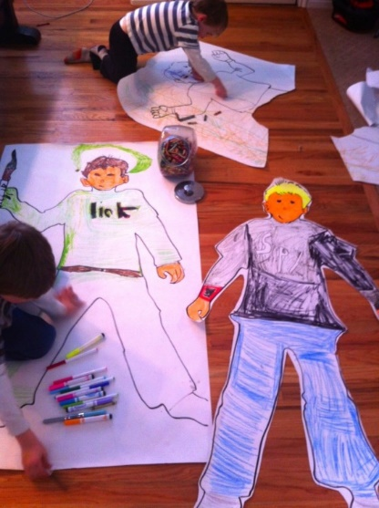
- Design a superhero – use the attached template if you can print it out or draw it on paper. If you have any big paper such as a roll of old wallpaper, you could draw around a real person and draw in all their superhero body parts.

Phonics
- Have a go at this listening game
https://www.phonicsplay.co.uk/resources/phase/1/welcome-to-the-zoo
- If your child is due to start Reception in September, you may want to show them some of these phonics videos, using the links below. The videos are made by ‘Read, Write, Inc’, which is the phonics scheme that we use.

We normally begin to introduce the first sounds to children in nursery in the summer term, after Easter…but if your child is interested in letters now, then there is no harm in starting early. If your child shows no interest in the videos, please don’t panic…try again in a few weeks or we will try again in the summer term:
e = https://schools.ruthmiskin.com/training/view/UzZMB6rV/nXTfzQtx
l = https://schools.ruthmiskin.com/training/view/42jjFKZD/fzZS6GKe
h = https://schools.ruthmiskin.com/training/view/bVKEkeVd/PgMKhFr6
r = https://schools.ruthmiskin.com/training/view/nRcUv2iQ/jf8K5QX4
j = https://schools.ruthmiskin.com/training/view/9XvLcDbg/bl7tHcQb
Fine Motor Challenges
Can you have a go at all 3 challenges this week?
- Squeeze some oranges to make orange juice ice cubes / mini ice lollies for superhero strength.
- Make some superhero pegs. Where can you peg them onto around your home?
- Snip some small pieces of paper to make your super hero mask.
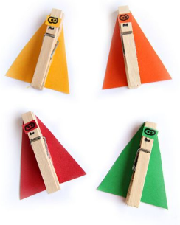
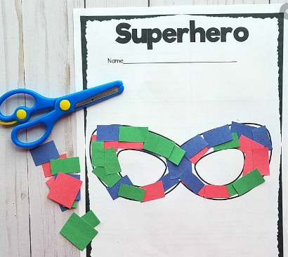

Have fun everyone!
You’re all AMAZING!

