30.03.21 Challenge
Percentage – missing values

Use a bar model to help you solve the following problems.
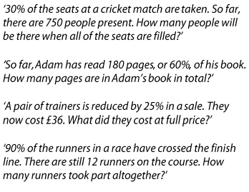
1.

2.

3.

4.

30.03.21 Challenge
Percentage – missing values

Use a bar model to help you solve the following problems.
1.

2.

3.

4.

30.03.21 Challenge
Percentage – missing values

Use a bar model to help you solve the following problems.
1.

2.

3.

4.

30.03.21 Challenge
Percentage – missing values

Use a bar model to help you solve the following problems.
1.

2.

3.

4.

