21.01.2022
L.O I can subtract numbers up to 20.
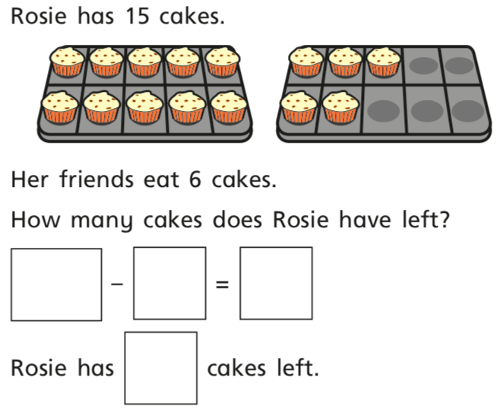

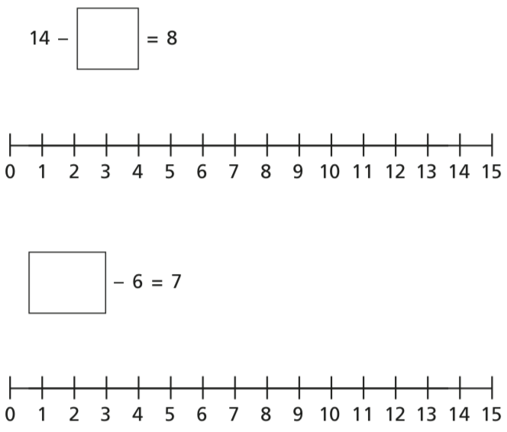
- Fill in the missing numbers.

