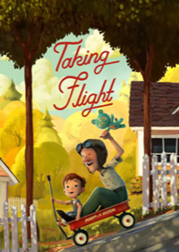
Taking Flight

grandpa | dangerous | magnificent
adventure | laser | dedicated
garage | battle | curious
jungle | spaceship | vivid
alien | exciting | elderly

