L.O. Identify features of characterisation
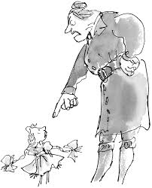
Characterisation: Miss Trunchbull, Amanda and Bruce
Examples of how Roald Dahl shows characterisation
Actions/ reactions of characters
Appearance of characters
Internal voice
Dialogue

