Wednesday 2nd February 2022
LO: To deepen our understanding of the text.
LO: To use a thesaurus.
What do the words mean?
★ Let’s take a look at the meaning of some of the words in my diary.
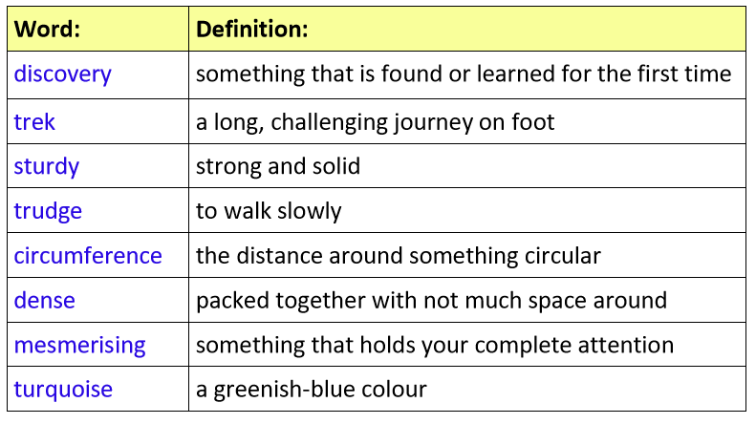
Use an example
★ Look at the definitions above. Draw a picture in each box below that could represent the word in the box.
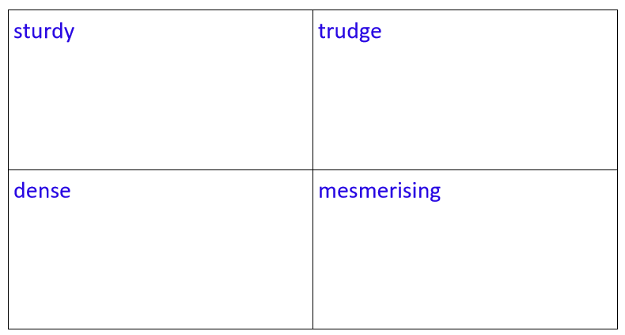

Which synonym?
★ Synonyms are words with the same or similar meanings. Match the synonyms below this table to the target words.
★ Can you find any more synonyms to add into the table?
