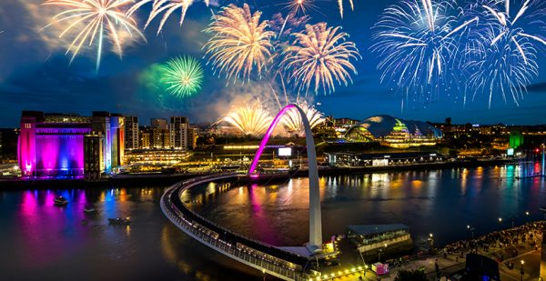

Bang, boom, poof! Florescent fireworks burst in the inky, night sky like shooting stars. The luminous fireworks crackle down like weeping willow and fill the vast sky. The calm River Tyne flows gently like a snake about to ambush its prey. The buildings stand tall like saluting soldiers. The Sage lies like a giant, frozen caterpillar observing the dazzling fireworks. Sparkling embers soaring through the sky on this magnificent Bonfire night.

