What did the Resurrection mean to early Christians?
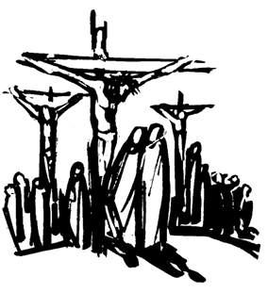
Christians today celebrate Easter Sunday as the day that they believe Jesus defeated death and came back to life - the Resurrection. However, the first Christians - the original followers of Christ - experienced a whole range of emotions at the time. Jesus had already told them that he would die on a cross and that he would rise from the dead after three days, which must have been confusing and deeply upsetting for his followers.
Subsequently, they all watched him be crucified and die painfully; they then mourned, as he was taken down and laid in a tomb with a large rock placed over the entrance. The following events are recounted in the book of Matthew, chapter 28, in the New Testament of the Bible.
It was Jewish tradition to wash a dead body before it was buried, but because the next day was Saturday, a day of rest (the Sabbath), Jesus was left unwashed and no-one went to visit the tomb. Only some Roman soldiers were there to guard it.
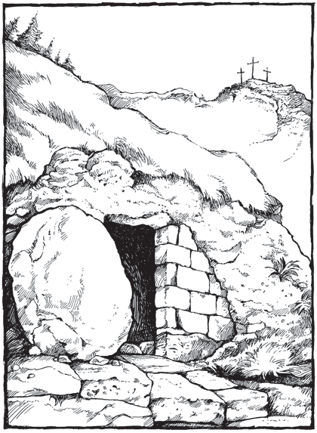
Early on Sunday morning, Mary Magdalene, a devoted follower of Jesus, and some of his other disciples went to the tomb to prepare his body. As they approached, the ground started to shake. The women and the guards were terrified but then to add to their distress, they saw what seemed to be an angel, appearing in a bright flash.
Before they could do anything, the heavy stone was rolled from the entrance of the tomb and the angel sat on top of it.
He said, "Do not be afraid. Jesus is not here; he has been raised from the dead."
They then saw the white cloths that Jesus had been wrapped in, lying in a heap in the empty tomb. The angel told them to go and tell the good news to the others.
Mary and her friends hurried back in amazement, but then they saw Jesus himself. "Do not be afraid," he said. He also told them to tell the other disciples about what had happened.

