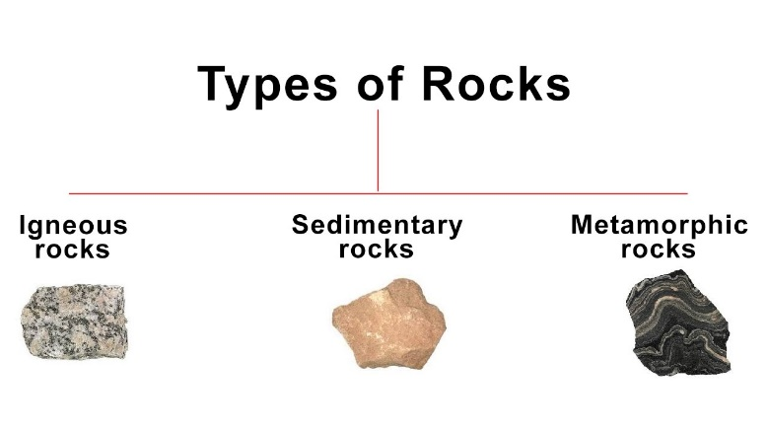
Tuesday 16th March
LO: I can name the three different types of rocks.
LO: I can explain the difference between natural and human-made rocks.
LO: I can use the appearance of rocks to group and compare them.
Natural or Human-Made Rocks

