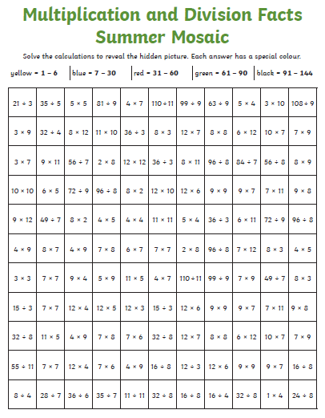

Factors and multiples
https://nrich.maths.org/factorsandmultiples

