LO:To learn to write Instructions
Here is a copy of the text we have been learning and an example text map:

How To Make Turkish Delight
The sticky, soft, chewy sweet is usually incredibly floral with the flavours of rose water or orange blossom... but this version takes a green twist with Pandan extract and elderflower. Whether you know of it from Narnia or street markets and stalls across Europe and North Africa... when dusted in icing sugar and cornflour everybody want a square!
Ingredients
- 850 ml cold water
- 800 g caster sugar
- 1/4 lemon (juiced)
- 160 g cornflour
- 1 tsp cream of tartar
- 2 tbsp elderflower cordial
- 1 drop pandan extract
- 1 handful pistachio nuts
- 120 g icing sugar
- 30 g cornflour

Method
- First, dissolve the caster sugar into 350ml of the water and the juice from the quarter of a lemon in a deep saucepan over the stove. Carefully heat until the mixture reaches 118°C then take off of the heat.
- Next, dissolve the cornflour and cream of tartar in the leftover 500ml of cold water in a separate saucepan then heat to a boil as you whisk. As the mixture thickens, keep stirring slowly.
- Then, pour the sugar syrup into the cornflour paste slowly but surely, mixing well as you do it. It might go lumpy, but keep whisking. Heat very gently (as low as it’ll go) for an hour by which time you’ll have a thick, slightly golden syrup.
- After that, stir in the cordial and pandan, then mix in the pistachio nuts. Transfer to a lined and deep roasting tin (20cm x 20cm) and allow to cool and set for several hours.
- Finally, toss the icing sugar and cornflour together in a bowl. Cut the set Turkish delight into pieces and dust in a combination of the icing sugar and cornflour then serve or store in an airtight container.

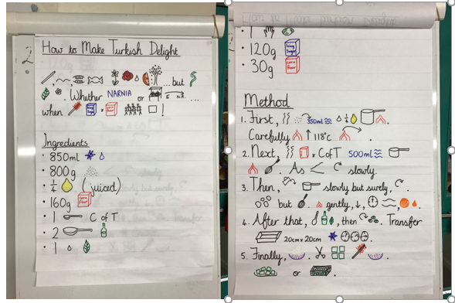

Monday – Write a revolting menu
Now that you have written your revolting recipe, can you design, write and decorate a menu for that and all the other revolting items that the White Witch will be serving at the ball? Remember to use interesting adjectives to describe the items e.g. slimy slug and squid eyeball sandwiches, sticky mud and fresh bogie cake covered in grated pig hair icing and shredded toenails, delicious smoothie made from pointed bats ears, dog drool (large dogs only) and stagnant pond water, mashed ant and fried grasshopper pancakes doused in blueberry and snot jam.

I’m sure you will come up with lots of revolting items to add to your menu. When you’ve written this out in your neatest handwriting, you can decorate it with images of the revolting food.

Tuesday – Wanted Poster
Imagine that you are the White Witch and you are desperate to track down any Daughters of Eve or Sons of Adam. Complete the wanted poster (attached below) to spread the word across Narnia! Don’t forget to include this information: Who are they? Describe them. Why do you want them to be caught and handed over to you? What should anyone do if they see them? Will you give a reward for their capture or will you punish those who don’t turn them in? Remember to add a picture!

Wednesday - independent ‘cold’ write – Defeating a Monster story.
In class today, the children will be writing without any help at all. We call this a cold write. We ask them to do this so that we can assess what they need to learn for this particular genre of writing. Today we would like you to do the same at home. Please write a story about ‘Defeating a Monster’ without any help.

Thursday – Definitions and Alphabetical Order.
Today you are going to create a Glossary of words from Narnia. When you begin to read The Chronicles of Narnia, you will come across many unusual words. Some of these words are old-fashioned and were used around the time C.S. Lewis was writing. Many of these words were used to describe mythical creatures, so we do not come across them very often. Use a dictionary to find definitions for the unusual words listed below. Then enter them into the table (attached) in alphabetical order to create your own glossary.

