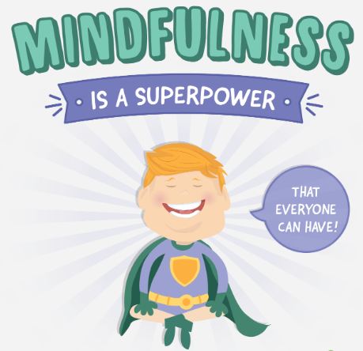
Nursery Home Learning

Week Beginning Monday 13th July

- The book ‘The Invisible String’ talks about an invisible string that connects those we love to us and it is a beautiful story. In our current situations it could be used to confirm how loved and connected your children are to their special people who they may not be able to see.

https://www.youtube.com/watch?v=_cO2LBBBtAI
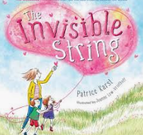

- This can be used to help support children in their transition back to school and to reassure them that they're loved and connected by the ‘invisible string’.

Here are some other stories which may support talking about their fears and feelings.
https://www.youtube.com/watch?v=JM27Zj04EOM  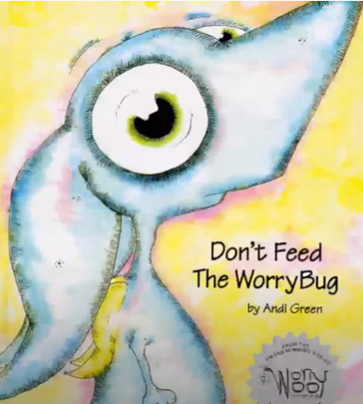 | https://www.youtube.com/watch?v=VCyiiHI2SJU  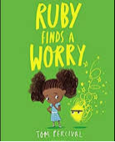
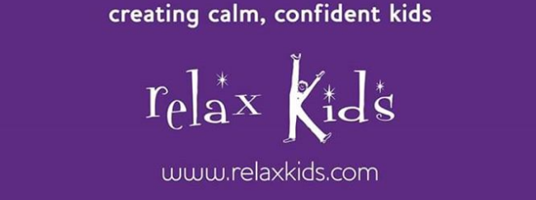

- Emma, who delivers our Relax Kids sessions in school, has sent a link to her Facebook page where she is posting some Mindfulness & wellbeing sessions.
This is the link - https://www.facebook.com/Relaxkidsderwentside/?ref=settings

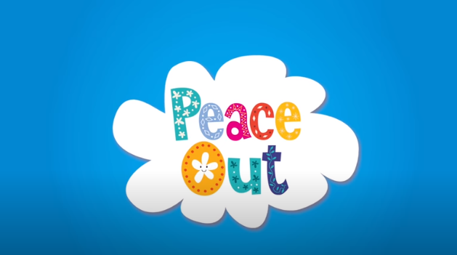

- Yoga is a great way to relax. Peace Out is guided relaxation design for children from Cosmic Kids Yoga. This is the link to the first session but there is a whole series on Youtube.
https://www.youtube.com/watch?v=ZBnPlqQFPKs

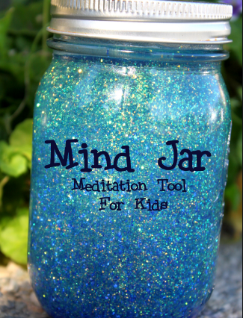
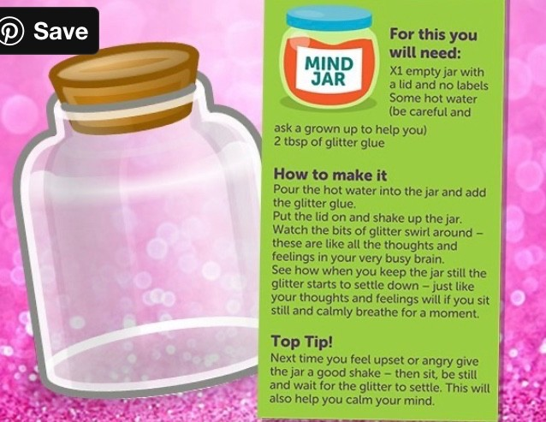

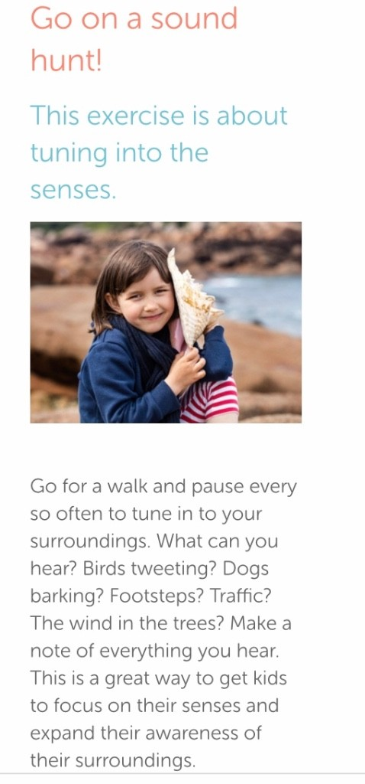

Breathing Awareness activity
- Children can stand or sit for this activity.
- Ask them to put both hands on their belly.
- Your child should close their eyes, or look down to their hands.
- Guide them in taking three slow deep breaths in and out to see if they can feel their hands being moved.
- You may like to count “1, 2, 3” for each breath in and “1, 2, 3” for each breath out, pausing slightly at the end of each exhale.
- Encourage children to think about how the breath feels, answering the following questions silently, in their mind.
– What is moving your hands? Is it the air filling your lungs?
– Can you feel the air moving in through your nose?
– Can you feel it moving out through your nose?
– Does the air feel a little colder on the way in and warmer on the way out?
– Can you hear your breath?
– What does it sound like?

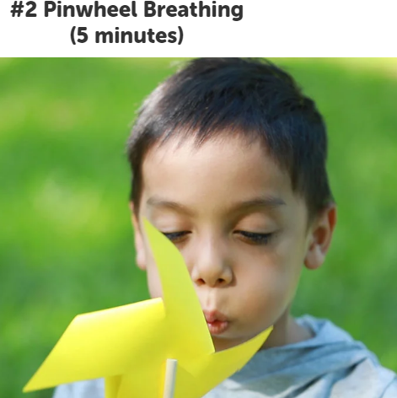
- Use a pinwheel/windmill with the mindful breathing exercise above, making the pinwheel spin with every exhale.

There is a template attached for children to create their own pinwheel/windmill.

Mindful Eats
- This is a great activity to bring attention to how mindlessly we sometimes eat! Whether sitting in front of the tv, chatting to friends at lunch, or scrolling through something on the internet or social media, we often “switch off” when eating because it is such a familiar action.
- Mindful eating can combat over-eating, it helps bring our attention to the flavours and tastes of different foods and helps us to realise what effects different foods have on how our bodies feel.
- You will need something small to eat for this activity. Often a square of chocolate is a fun “challenge”, although you could provide a piece of fruit or any food item that you feel will work with your child.
- Begin this practice with three deep breaths
- Direct child to take small nibbles or bites of the food.
- Bring awareness to the sensations of eating.
– What is the taste like? Is it sweet or savoury?
– What does the food feel like on your tongue?
– Do you need to crunch it between your teeth, or can you slowly dissolve it in your mouth?
– Try taking a slightly smaller or slightly larger bite.
– How does this change the way eating this food feels?
– Notice which muscles in your mouth, neck and body move as you swallow the food.
– Pause between each bite and notice any changing sensations in your mouth or body.

