Monday 12th October
LO: To punctuate sentences correctly

Use the words to write your own super sentences. Remember each sentence needs a full stop and capital letter.
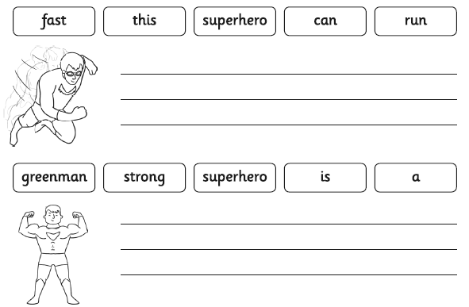

Read the description about Ice Girl. Can you use your green pencil to put capital letters and full stops in the right place?
