WC Monday 14th June
Content objective:
To know that plants grow from seeds
Me
Teacher
Skill objective:
To follow instructions and observe results
Me
Teacher
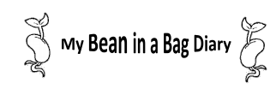

Today the date is:

My bean looks like:
Today the date is:

My bean looks like:

Today the date is:

My bean looks like:
Today the date is:

My bean looks like:

