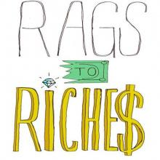
Friday 30th April
LO: To plan a rags to riches story (innovation)
Introduces the MC and his wish

MC is sad/lonely or treated badly

MC has to face difficulties

MC overcomes difficulties

MC achieves happiness

